Using the GPS/COM feature in SEGYJP2 viewer

SEGYJP2 Viewer has been extended to output NMEA-compliant GPRMC position strings though any available COM serial port. If a virtual serial port program is used to create a paired set of virtual COM ports, then this feature can be used to plot the active cursor position on the SEGYJP2 Viewer on a linked GIS such as ArcMap or Gloabl Mapper.

Setup a virtual COM port pair

There are a couple of ways to setup virtual COM ports on your computer ( Windows XP, Windows 7 ).

com0com is an open source virtual serial port emulator freely available on Sourceforge (http://sourceforge.net/projects/com0com) It will work with 32 or 64 bit Windows XP systems as well as 32 bit Windows 7/8 operating systems. My experience suggests that an earlier version of the software worked for me ( version 2.2.2.0 ) but you can try that latest version if you wish. The release includes online documentation. The release is a big buggy and sometimes locks up the program, so caveat emptor.

Use the default setting when first setting up a virtual serial port pair. You shouldn't need to do anything but press "Add Pair". Rename the default pair COM port name to the more standard convention, COMn, e.g., COM6

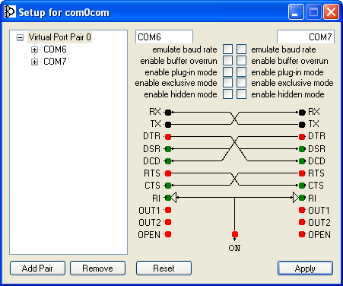
Use standard port names

Commercial Virtual Serial Port Programs

For 64 bit Windows 7/8 machines, you probably will have to buy a commercial virtual serial port program ( due to the cost of licensing drivers on these new operating systems). I have successfully used a program from Eltima Software (http://www.eltima.com/products/vspdxp/) . Based on my experience, this is the preferred option compared to the free version.

Follow the installation instructions and run the Configure Virtual Serial Port Driver utilty:

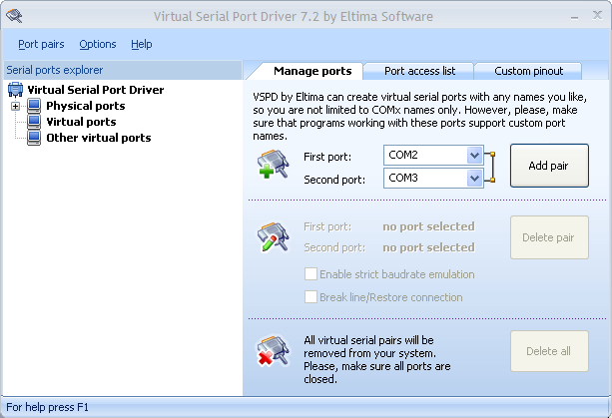
Eltima Virtual Serial Port Driver setup program

It should be as easy as pressing the "Add Pair" button

Setup in SEGYJP2 viewer

Launch a viewer window from the SEGYJP2 viewer as usual.

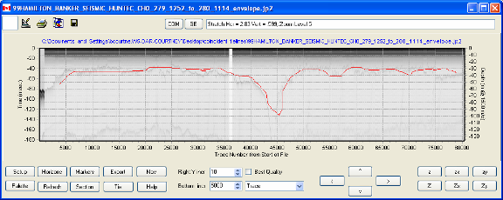
SEGYViewer display window

Two new buttons, COM and GE, have been added at the top next to the status line. For the moment, the GE ( Google Earth button is inoperative). Press the COM button to view the COM port control window:

Use the topmost combo-box box to choose on of the virtual port pairs that you have created :

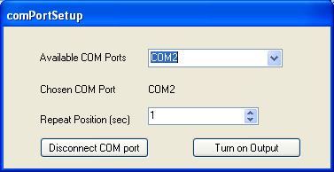
COM2 has been chosen as the output port

A NMEA string with the current position will be sent to the output port every 1 second if the "Turn on Output" button is toggled.

The string is repeatedly sent to keep the receiver program ( say, ArcGIS or Google Earth ) lock to the paired output port.

The "COM" button on the main viewer window will change its background colour to green when the port is enabled:

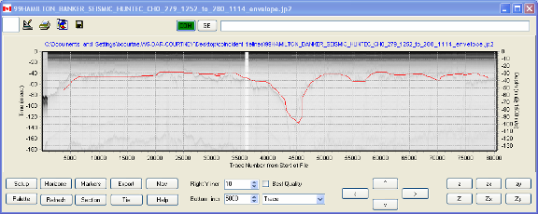
The green button indicates that a COM port is active.

The main display window COM button can be used to toggle the visibility of the COM port control window on or off.

Setup in ARCGIS

To use the GPS option is ARCGIS, choose Customize=>Toolbars=>GPS from the top menubar of the ArcMap display window :

Arcmap main display window

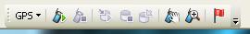
GPS toolbar.

Choose the "GPS" button to configure the port settings :
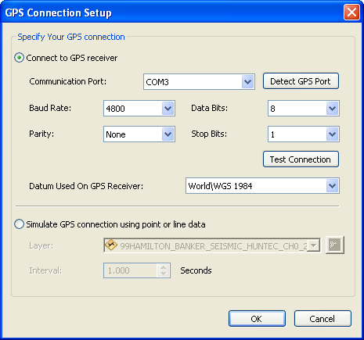

Choose the paired port that was set up earlier, in this case COM3. Press OK to continue.

You can use the Display Options button to configure the appearance of the active point on the screen.

Open the paired port using the button. Close the port using the button.

Remember to ensure that the output port ( in this case COM2, configure in the SEGYJP2 viewer COM port configuration window is configured to output points.

